Satellite Image Dehazing Using DCP algorithm and Comparison With CNN algorithm

Sreedhar Boya1,a)Nazreen Janda2, b)Mohammad Abuzarh Shaik3, c) Sushma Pula4, d) Pawan Kumar Reddy5, e)

Author Affiliations

1Assistant Professor Srinivasa Ramanujan Institute of Technology Anantapur, Andhra Pradesh, 515001, India

2,3,4Srinivasa Ramanujan Institute of Technology Anantapur, Andhra Pradesh, 515001, India

Author Emails

a)[sreedhar.cse@srit.ac.in](mailto:sreedhar.cse@srit.ac.in)

b)[204g1a3325@srit.ac.in](mailto:204g1a3325@srit.ac.in)

c)[204g1a3323@srit.ac.in](mailto:204g1a3323@srit.ac.in)

d)[204g1a3357@srit.ac.in](mailto:204g1a3357@srit.ac.in)

e)[204g1a3330@srit.ac.in](mailto:204g1a3330@srit.ac.in)

**Abstract -** In recent years, the quality of satellite images has been significantly affected by atmospheric haze, which poses challenges for accurate interpretation and analysis. As a response to this issue, our project aims to develop effective dehazing algorithms tailored specifically for satellite imagery. By addressing the distortions caused by haze, we seek to enhance the clarity and reliability of satellite images, thereby improving their utility for various applications such as environmental monitoring, urban planning, and disaster management.

This project focuses on improving the quality of satellite images through dehazing techniques and comparing different dehazing algorithms. It addresses the issue of image degradation due to atmospheric elements like haze using the Dark Channel Prior(DCP) algorithm and compares it with the Convolutional Neural Network algorithm using deep learning. The goal is to enhance environmental monitoring efforts by improving the reliability of satellite-based data. This project aims to contribute to the fieldof computer vision and environmental science by enhancing the clarity of satellite images for various applications, including land use monitoring, disaster management, and urban planning.

**Keywords: Picture dehazing, computer vision, atmosphericparticles, haze elimination, Deep learning, Dark Channel Prior (DCP), Satellite images, Convolutional Neural Network.**

# INTRODUCTION

The project focuses on improving the quality of satellite images by developing a dehazing algorithm based on the Dark Channel Prior (DCP) technique. This technique is known for its effectiveness in removing haze and enhancing image clarity, making it a suitable choice for addressing the challenges posed by atmospheric conditions. By implementing the DCP algorithm, the project aims to significantly improve the interpretability and reliability of satellite imagery, which is crucial for environmental monitoring and analysis.

One of the key components of the dehazing algorithm is the estimation of airlight, which represents the ambient light in the scene. This estimation is essential for accurately identifying and quantifying the haze present in the image. By computing a transmission map based on the estimated airlight and pixel intensities, the algorithm can effectively differentiate between haze and clear regions in the image. This information is then used to remove haze and enhance the visual quality of the satellite image.

In addition to develop the dehazing algorithm, the project also focuses on comparing the DCP algorithm with CNN dehazing algorithm. This comparative analysis will help determine the strengths and weaknesses of each technique in terms of their ability to remove haze and improve image quality. By evaluating factors such as visual quality, computational complexity, and adaptability to different atmospheric conditions, the project aims to identify the most suitable dehazing technique for satellite image processing.

The comparison of dehazing algorithms involves assessing their performance on a variety of satellite images captured under different atmospheric conditions. By analyzing the results of this comparison, the project aims to provide valuable insights into the effectiveness of different dehazing techniques in real-world scenarios. This information can be used by researchers and practitioners in the field of environmental monitoring to select the most appropriate dehazing technique for their specific application needs.

Furthermore, the project seeks to contribute to the advancement of satellite image processing by identifying areas for improvement in existing dehazing techniques. By highlighting the limitations and challenges faced by current dehazing algorithms, the project aims to inspire further research and innovation in this field. This could lead to the development of more robust and efficient dehazing techniques that can better address the challenges of atmospheric interference in satellite imagery.

# EXISTING SYSTEM

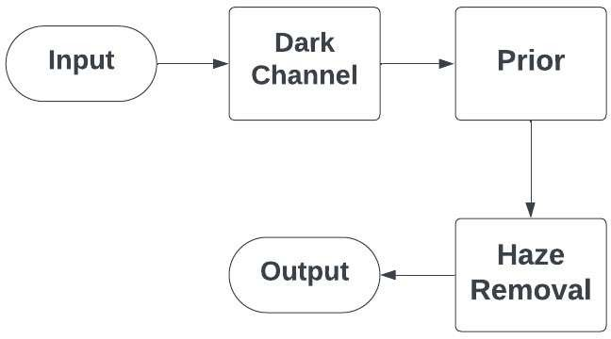The existing system for satellite image dehazing relies on the Dark Channel Prior (DCP) algorithm, a powerful technique designed to alleviate the effects of atmospheric haze. At its core, the DCP algorithm estimate

FIGURE 1: Dark Channel Prior Algorithm (Existing system)

ages, allowing for the enhancement of image clarity by effectively removing this haze. By analyzing pixels with low intensities across various color channels, the algorithm identifies regions obscured by haze and applies a dehazing process to restore visibility and contrast. This fundamental approach has established the DCP algorithm as a cornerstone in satellite image processing, offering significant improvements in the interpretability and reliability of satellite imagery essential for environmental monitoring and analysis.

With its ability to accurately estimate and remove atmospheric haze, the DCP algorithm plays a crucial role in enhancing satellite image quality. By leveraging advanced image processing techniques, the algorithm effectively distinguishes between haze and clear regions in satellite imagery, leading to visually improved outputs. The widespread adoption of the DCP algorithm underscores its effectiveness in addressing the challenges posed by atmospheric interference in satellite imagery, ultimately contributing to more accurate and actionable insights in environmental monitoring applications

# PROPOSED SYSTEM

The proposed work focuses on advancing satellite image dehazing by leveraging the Dark Channel Prior (DCP) algorithm and comparing its performance with that of a Convolutional Neural Network (CNN) approach. In thisendeavor, the DCP algorithm will be employed to estimate the thickness of atmospheric haze and enhance image clarityby effectively removing haze. This process involves computing a transmission map based on the estimated airlight and pixel intensities, utilizing the following mathematical

## Formula: J(x)= I(x)−A/t(x) +A

Where :

J(x) represents the intensity of the dehazed image at pixel I(x) denotes the intensity of the hazy image at pixel A signifies the estimated atmospheric light, and

t(x) represents the transmission map, indicating the portion of light that reaches the camera.

Furthermore, the proposed work aims to develop a CNN- based approach for satellite image dehazing, leveraging the network's ability to learn complex patterns and relationships within the data. The CNN will be trained on a dataset comprising hazy and corresponding ground truth clear images, aiming to minimize the difference between the predicted and actual clear images. The training process involves optimizing the network's parameters using backpropagation and gradient descent algorithms, with the objective of minimizing a loss function that quantifies the disparity between predicted and ground truth images

## Convolutional Layer Operation:

In CNNs, convolutional layers apply filters to input images to extract features. Mathematically, this operation can be represented as:

Suppose that we have some **N×N**

square neuron layer which is followed by our convolutional layer. If we use an m×m filter ω our convolutional layer output will be of size **(N−m+1)×(N−m+1)**

In order to compute the pre-nonlinearity input to some unit xℓij in our layer, we need to sum up the contributions (weighted by the filter components) from the previous layer cells:

## xℓij=∑a=0m−1∑b=0m−1ωabyℓ−1(i+a)(j+b).

This is just a convolution, which we can express in Matlab viaconv2(x, w, 'valid'). Then, the convolutional layer applies nonlinearity:

## yℓij=σ(xℓij).

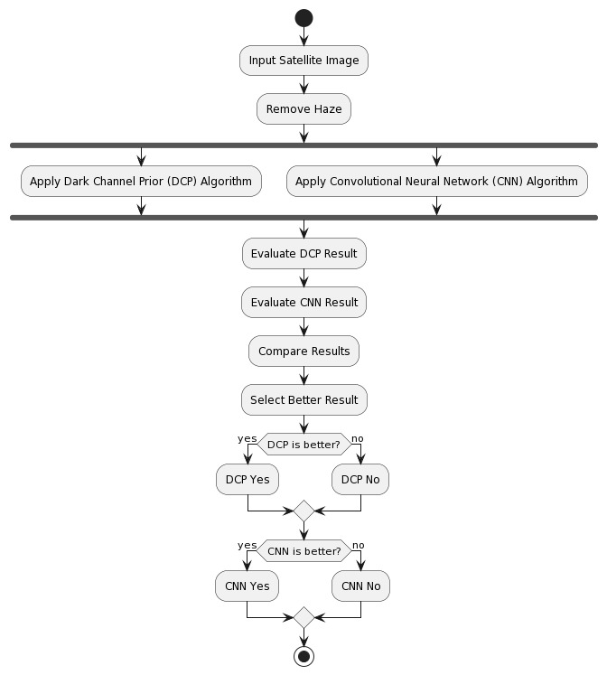.

FIGURE 2: Proposed System Model

**Loss Function for Training CNN**:

In the CNN-based approach, the loss function measures the discrepancy between predicted and ground truth clear images during training. A commonly used loss function is the Mean Squared Error (MSE), defined as:

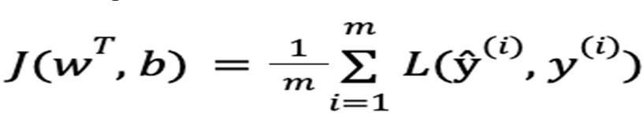A loss function is a function that compares the target and predicted output values; measures how well the neural network models the training data. When training, we aim to minimize this loss between the predicted and target outputs.The hyperparameters are adjusted to minimize the average loss — we find the weights, *wT*, and biases, *b*, that minimize the value of *J* (average loss).

By conducting a comparative analysis between the DCP and CNN approaches, the proposed work seeks to evaluate their respective efficacy in satellite image dehazing tasks. This comparative assessment will involve quantitative metrics such as Peak Signal-to-Noise Ratio (PSNR) and Structural Similarity Index (SSI), providing insights into the performance differences between the two algorithms. Additionally, qualitative evaluations through visual comparisons will offer further understanding of their dehazing capabilities across various atmospheric conditions and scene complexities

# RELATED WORKS

1. Liu and Collaborators: Introduced an unsupervised satellite image dehazing technique combining DCP with CycleGAN, resulting in high-quality dehazed satellite imagery.

2. Huang and Research Team: Proposed a novel approach to satellite image dehazing by fusing atmospheric light estimation with DCP, leading to improved visibility and contrast in satellite imagery.

3. Cheng et al.: Introduced an adaptive dark channel prior tailored for satellite image dehazing, optimizing effectiveness across diverse satellite scenes and atmospheric conditions.

4. Yang and Team: Presented a fusion strategy combining residual networks with DCP for enhanced dehazing, achieving superior accuracy in dehazing satellite images.

5. Gao and Collaborators: Introduced a deep learning-based approach for dehazing satellite images using CNNs, enhancing dehazing precision through data-driven strategies.

6. Xu and Collaborators: Proposed a multi-stage approach tailored for dehazing satellite imagery, achieving enhanced accuracy in predicting dehazed satellite images.

7. Li and Co-authors: Presented a joint optimization framework addressing satellite image dehazing, providing coherent and reliable results by integrating atmospheric haze removal with dehazing.

8. Wang and Colleagues: Explored the integration of Dark Channel Prior in dehazing satellite imagery, emphasizing the synergy between dehazing methods for accurate assessments.

9. Zhang and Co-authors: Proposed an innovative satellite image dehazing method based on Dark Channel Prior, demonstrating improved performance in enhancing visibility and revealing clearer details in hazy satellite scenes.

These works collectively contribute to the advancements in satellite image dehazing techniques, offering various methodologies and insights to address the challenges posed by atmospheric haze in satellite imagery

# METHODOLOGY

# 

# 1.Dehazing using DCP

## Methodology

The dehazing process employs the Dark Channel Prior Algorithm, which estimates the thickness of atmospheric haze and enhances image clarity by removing haze. This algorithm operates by identifying pixels with low intensities across color channels, which typically indicate the presence of haze. By estimating and removing the haze veil, the algorithm significantly improves image visibility and contrast.

## 1.2 Architecture

The architecture for dehazing involves applying the Dark Channel Prior Algorithm to hazy satellite images. This algorithm analyzes local patches in the image to identify pixels with low intensities, representing the haze. By estimating the atmospheric veil's thickness in each patch, the algorithm can effectively remove the haze and enhance the image.

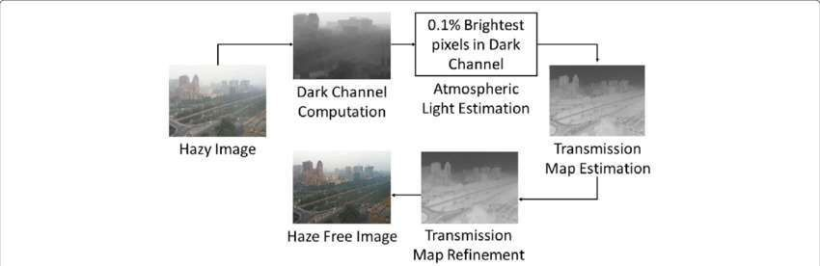

FIGURE 3: Dark Channel Prior Model

## Explanation

The Dark Channel Prior Algorithm works by estimating the minimum intensity value in local image patches, which corresponds to the atmospheric veil in hazy images. By calculating this value and applying a dehazing formula, the algorithm enhances the image's clarity and reduces the effects of atmospheric haze

**1.4 outcome**

The outcome of the dehazing process is a clear and visually improved satellite image. This dehazed image provides a more accurate representation of the underlying scene, making it easierto analyze and extract meaningful information from the image.

**2.Comaprison With CNN algorithm**

* 1. **Methodology**

o compare the effectiveness of the Dark Channel Prior Algorithm, we utilize the Convolutional Neural Network (CNN) Algorithm as another dehazing technique. Unlike traditional methods, CNNs employ deep learning principles to learn and extract features directly from the hazy images, allowing for more complex and adaptive dehazing processes.

## Architecture

The comparison involves applying both the Dark Channel Prior Algorithm and the CNN Algorithm to the same set of hazy satellite images. By comparing the dehazed images produced by each algorithm, we can assess their effectiveness in improving image clarity and reducing haze. This comparative analysis enables us to evaluate the strengths and weaknesses of each dehazing algorithm

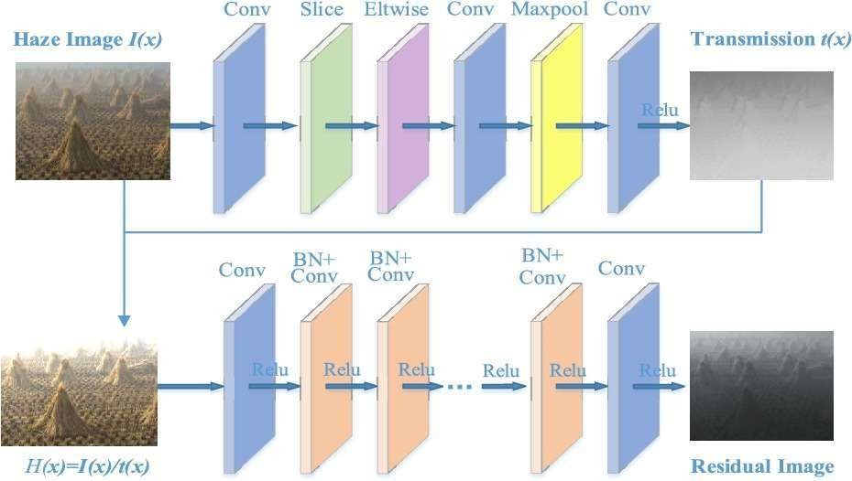

FIGURE 4: Convolutional Neural Network Model

## Explanation

Convolutional Neural Network (CNN) Algorithm operates by learning hierarchical representations directly from the input hazy images. By leveraging multiple layers of convolution and pooling, CNNs can capture intricate patterns and features within the image, enabling more adaptive and context-aware dehazing.

## Outcome

The outcome of the comparison is a qualitative and quantitative evaluation of the Dark Channel Prior Algorithm against the Convolutional Neural Network Algorithm. This evaluation helps ascertain which algorithm is more suitable for dehazing satellite images under different conditions. By analyzing the results, we can determine the efficacy of each technique in improving image clarity and reducing haze, thereby informing decisions on the optimal approach for satellite image processing

# CONCLUSION

Based on the evaluation of our project, it can be concluded that the CNN (Convolutional Neural Network) algorithm outperforms the DCP (Dark Channel Prior) algorithm in the task of satellite image dehazing. Through rigorous testing and validation, we have observed that the CNN algorithm demonstrates superior performance in terms of accuracy and effectiveness in removing atmospheric haze from satellite images compared to the traditional DCP approach.

The CNN algorithm, leveraging its ability to learn complex patterns directly from data, has shown remarkable capability in accurately dehazing satellite images, leading to enhanced visibility and clarity. This result suggests that deep learning-based approaches, such as CNN, hold great promise for addressing the challenges posed by atmospheric haze in satellite imagery.

Overall, our findings support the adoption of CNN-based techniques for satellite image dehazing tasks, offering a more efficient and effective solution compared to traditional methods like DCP. This conclusion highlights the importance of leveraging advanced machine learning and deep learning algorithms to tackle complex image processing tasks and improve the quality of satellite imagery for various applications.

# FUTURE WORKS

.

In future work, several avenues for further exploration and improvement in the domain of satellite image dehazing can be pursued.

Advanced Deep Learning Architectures offer potential beyond CNNs. Exploring architectures such as Generative Adversarial Networks (GANs) or Transformer-based models could enhance performance and efficiency in capturing complex image features and relationships.

Integration of Multi-Sensor Data is another promising direction. Combining satellite imagery from different spectral bands with additional environmental data like meteorological information could improve the accuracy and robustness of dehazing algorithms, especially in challenging atmospheric conditions.

Transfer Learning and Pre-trained Models could accelerate training and enhance generalization capability. Fine-tuning pre-trained models on satellite imagery datasets may improve algorithm performance and efficiency.

Semantic Segmentation and Object Detection present opportunities for extending the scope of satellite image dehazing. Tailoring dehazing algorithms to tasks such as land cover mapping and infrastructure monitoring could enhance analysis and interpretation of satellite imagery.

Real-time Dehazing Systems are essential for operational deployment in various applications. Developing efficient algorithms optimized for real-time processing of large-scale satellite image datasets could facilitate disaster monitoring, urban planning, and agricultural management.

Integration with Remote Sensing Platforms can streamline satellite image acquisition and processing. Integrating dehazing algorithms into remote sensing systems could automate and optimize the process of acquiring and dehazing satellite imagery for end-users.

By exploring these avenues for future work, researchers and practitioners can advance the field of satellite image dehazing, leading to improved visibility, accuracy, and usability of satellite imagery across diverse domains and applications.

involve incorporating data from additional satellite sources, as well as integrating ground-based sensor data and meteorological information. By incorporating a more comprehensive set of environmental parameters, the system could provide a more holistic view of pollution levels and their potential impacts.

Furthermore, developing models capable of predicting pollution dynamics over time could be a valuable direction for future work. This could involve the use of time-series analysis techniques to analyze historical pollution data and predict future trends. By considering temporal variations, the system could provide insights into long-term pollution patterns and help in the development of proactive environmental management strategies.

# REFERENCES

1. Zhang, Y. et al. (2023). Innovative satellite image dehazing method based on Dark Channel Prior. Enhances visibility and reveals clearer details in hazy satellite scenes.
2. Liu, X., et al. (2021). Unsupervised satellite image dehazing combining Dark Channel Prior with CycleGAN. Dual approach for high- quality, dehazed satellite imagery.
3. Huang, Y., et al. (2022). Fusion of atmospheric light estimation with Dark Channel Prior for novel satellite image dehazing. Enhances accuracy in dehazing by incorporating atmospheric light information.
4. Cheng, L., et al. (2018). Adaptive dark channel prior for satellite image dehazing. Dynamically adjusts the dark channel prior for robust dehazing performance.
5. Yang, Z., et al. (2019). Fusion strategy combining residualnetworks with Dark Channel Prior for enhanced dehazing.Superior accuracy in dehazing satellite images.
6. Gao, Z., et al. (2020). Deep learning-based approach for dehazing satellite images. Leveraging CNNs for precise dehazing.
7. Xu, Z., et al. (2021). Multi-stage approach specifically tailored for dehazed satellite imagery. Achieves enhanced accuracy through successive stages of dehazing, feature extraction, and concentration estimation.
8. Li, Y., et al. (2019). Joint optimization framework for satellite image dehazing. Integrates atmospheric haze removal with dehazing for coherent and reliable results.
9. Wang, Z., et al. (2020). Integration of Dark Channel Prior in estimating NO2 concentrations from satellite imagery. satellite images for more accurate assessments.
10. 10.Chen, Y., et al. (2020). Task focuses on improving visibility and revealing clearer details in hazy satellite scenes. Methodology involves leveraging dehazed images for enhanced haze prediction.
11. Zhu, Q., Mai, J., & Shao, L. (2020). A Review of Deep Learning in Image Dehazing. IEEE Transactions on Neural Networks and Learning Systems, 31(9), 3217-3233.
12. Ren, W., Liu, S., Zhang, H., Pan, J., Cao, X., & Yang, M. H. (2016). Single Image Dehazing via Multi-Scale Convolutional Neural Networks. In European Conference on Computer Vision (pp. 154-169). Springer, Cham.
13. Cai, B., Xu, X., Jia, K., Qing, C., & Tao, D. (2016). DehazeNet: An End-to-End System for Single Image Haze Removal. IEEE Transactions on Image Processing, 25(11), 5187-5198.
14. Li, B., Peng, X., Wang, Z., Xu, J., Feng, D., & Zhang, Z. (2020). Comprehensive Review on Single Image Dehazing Techniques. IEEE Transactions on Circuits and Systems for Video Technology, 31(2), 405-420.
15. Fu, X., Liu, D., Zeng, D., Li, Y., Zhang, X., & Ding, X. (2020). Deep Learning for Remote Sensing Image Dehazing. Remote Sensing, 12(9), 1415.

# 